 | 12.1.25 Editors - Geometry Nodes Editor - Header - Add Menu - Grease Pencil - Operations
Table of content
Detailed table of content 1
Add menu - Grease Pencil - Operations 2
Grease Pencil to Curve 2
Merge Layers 2

Detailed table of content
Detailed table of content
Detailed table of content 1
Add menu - Grease Pencil - Operations 2
Grease Pencil to Curve 2
Inputs 2
Grease Pencil 2
Selection 2
Layers as Instances 2
Outputs 2
Curves 2
Merge Layers 2
Grease Pencil 2
Selection 2
Group ID 3
Properties 3
Mode 3
By Name 3
By Group ID 3
Outputs 3
Grease Pencil 3

Add menu - Grease Pencil - Operations
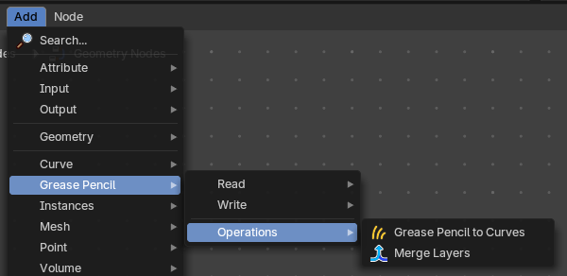
Grease Pencil nodes.

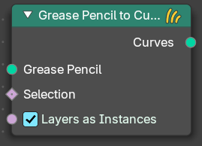
Grease Pencil to Curve
Converts a grease pencil geometry to a curve geometry

Inputs

Grease Pencil
The grease pencil geometry.

Selection
A selection of the grease pencil geometry.

Layers as Instances
Generate a separate curve instance for every layer.

Outputs

Curves
Curves output.

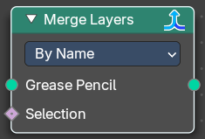
Merge Layers
Merge all grease pencil layers into one layer

Grease Pencil
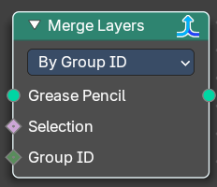
The grease pencil geometry.

Selection
A selection of the grease pencil geometry.

Group ID
In By Group ID mode. Input a group ID value.


Properties

Mode

By Name
Combine all layers which have the same name.

By Group ID
Combine all layers by a provided Group ID.

Outputs

Grease Pencil
Grease Pencil geometry output.

